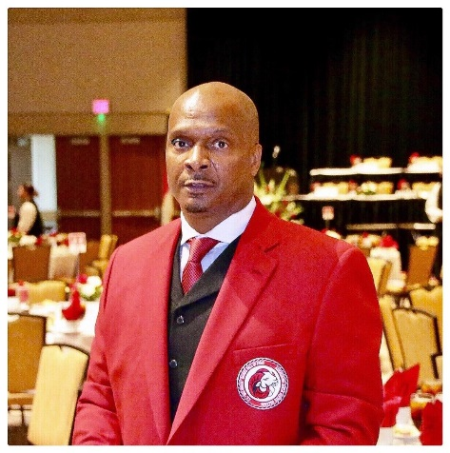
Anthony Blaylock
President and CEO of Blaylock Commercial Holdings, LLC
City of Atlanta

Anthony D. Blaylock was born and raised in Raleigh, NC where at an early age he began his passion for the game of football. Anthony graduated from Raleigh Public School System where he received a full scholarship to Winston Salem State University where he was “All CIAA” for 3 years and “All American” Honorable Mention his Senior year. In 1987 Anthony was drafted for the position of Cornerback for the Cleveland Browns.
Anthony Blaylock is the President and CEO of Blaylock Commercial Holdings, LLC, and its subsidiaries which include IHN Construction and Development, LLC, and IHN Enterprises, LLC. Mr. Blaylock has over 20 plus years of experience with a concentration on Development and Finance. Mr. Blaylock has provided equity and expertise in a vast number of projects ranging from SFR to larger commercial transactions.
Prior to forming Blaylock Commercial Holdings, LLC and its subsidiaries, Mr. Blaylock was a “Star Athlete” in the National Football League (NFL) with the Cleveland Browns, San Diego Chargers, and Chicago Bears. He is also a member of the college Hall of Fame at his Alma Mater, Winston-Salem State University.
Anthony was one of the founders of Powerhouse Sports Restaurant (Sold in 1999). He spearheaded the development of Dark Fiber and DSL Communications to form World Net Work Solutions (world-wide business including France, Africa, Australia, and Mexico). He inspired and assisted in the start-up of Landmark Bank. Mr. Blaylock is also the CEO of Bill and Martha Freeman Outreach, Inc. a Non-Profit Organization (501c3) located in Atlanta, GA. He spearheaded the startup of Intervu a video streaming company that was sold to Akamai technology (AKAM) for 2.8 billion dollars.

Anthony is also committed to the communities in which he serves. He is an advocate for Community Youth Programs. He is also a third degree black belt, who trained and taught martial arts Tae Kwon Do. He continues to make charitable contributions, and was honored by the Mayor of the City of Atlanta and given a proclamation declaring January 30th as Anthony Blaylock Day in the City of Atlanta. Mayor of the City of Atlanta and given
Anthony’s strong family foundation and his faith in God have allowed him success in both his personal life, but also in his professional career.by tayor of the City of Atlanta and gen

